**Mouse Wall Mount head**

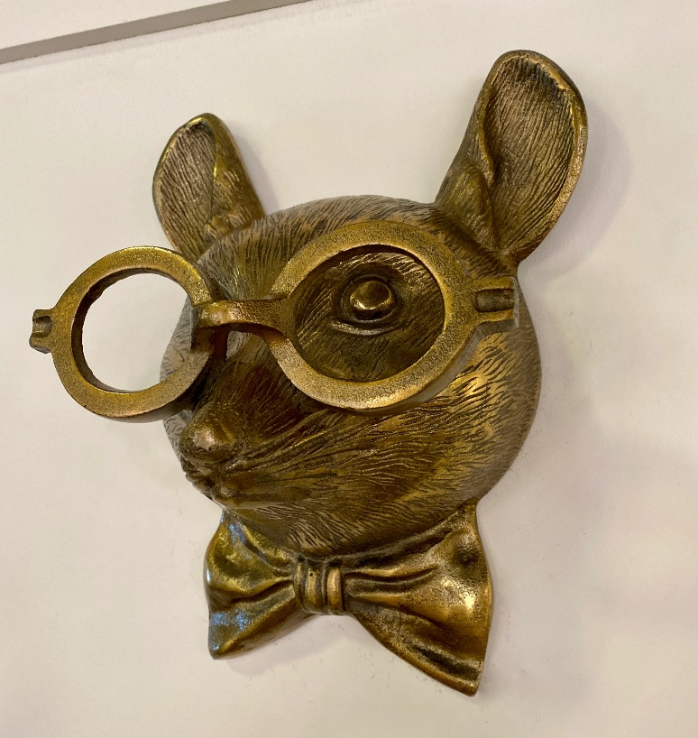A mouse wall mount head is a whimsical and playful decor piece that adds charm and personality to any space. Designed with delicate features like oversized ears, a petite nose, and subtle detailing, this piece is often crafted from materials such as resin, wood, or felt. Available in a range of styles, from realistic finishes to fun, cartoonish designs, a mouse wall mount is perfect for children's rooms, nurseries, or eclectic interiors. Whether minimalistic or colorful, it brings a touch of lightheartedness and creativity to walls, making it an adorable and unique addition to home decor.